PERCEPTION OF BRAZILIAN CONSUMERS REGARDING THE REPLACEMENT OF ANIMAL PROTEIN BY ALTERNATIVE VEGETABLE SOURCES

ABSTRACT
Behavior and perception consumers’ about the potential use of alternative sources can guide the development of foods tasty, healthy, and sustainable, such as ice cream. In this context, the objective of the study was to explore the perceptions of consumers from different regions of Brazil (n=212) regarding the use of raw materials from different native biomes through the application of an online questionnaire. From the results, it is possible to infer that consumers understand that the use of native sources can drive the development of diversified plant-based foods using alternative sources aligned with consumer demands. Environmental sustainability, income generation for local populations, and health concerns were the main factors pointed out to justify the use of these native sources. In addition, the interest in consuming plant-based products has increased mainly in groups that are not always the target of this market, with the appeal of being healthier and sustainable without giving up the flavor and sensory experience that involves their consumption. Thus, the valorization of these raw materials can encourage the sustainable exploitation of these resources and foster regional socioeconomic development, through the development of new products.

INTRODUCTION
Ice cream is a widely consumed product in many parts of the world, and is a very popular and diverse product, widely consumed for its sensory experience and nutritional value. (1, 2, 3). Due to the expansion of the plant-based market, the plant-based ice cream segment has been boosted.
Despite all the challenges involved in developing plant-based products in this category, a diversity of products is often offered to consumers, who are increasingly looking to make food choices that positively impact their health and the environment, yet deliver taste and indulgence. According to PINTO et al. (4), consumers no longer seek to restrict certain foods from their diet, but rather replace them with healthier options, which has fueled this global trend that involves the expectations and beliefs that a healthier diet can generate health benefits for consumers.
In this context, there is the opportunity to stimulate the development of new products from native plant species, distributed among the Brazilian biomes, with little explored functional and nutritional potential, which enables a wide variety of combinations between species. The development of products from the prospecting of new raw materials promotes innovation and sustainability in the food production chain. In addition to studying new sources and expanding the number of products on offer, knowing and understanding the consumers' perception of products that substitute a vegetable for animal protein is essential to the success of this market. The knowledge of which factors are considered more important during the process of choice and acceptance of plant-based products by consumers has been the subject of several studies: meat products (5, 6) plant-based milk (7) plant-based ice creams (8).
There are several useful tools to capture consumer perceptions quickly and practically, among them questionnaires. Studies exploring the preferences, perceptions, and behaviors of various groups regarding new plant-based products have been conducted using questionnaires (9, 10). In addition, the answers obtained through this survey help in the development of foods more aligned with the consumers' desires, since it allows to listen to them while designing a new product, being a tool to design marketing strategies to reach different consumer segments and to stand out in a competitive market such as the plant-based products (8). Thus, the use of methodologies such as the application of questionnaires may be interesting to gain insights into perpections consumers’ about to native plant sources little used and that has the potential to contribute to the diversification of plant-based ice creams.

OBJECTIVE
This work aimed to investigate the perception of Brazilian consumers about the use of native plant sources from different biomes in the development of plant-based ice creams.

METHODOLOGY
The research was approved by the Ethics Committee on Human Research of the Federal University of Viçosa (UFV), consubstantiated opinion number 5.291.419. To survey the opinion of consumers regarding the use of native sources from the Brazilian biome, in the development of plant-based ice cream, a questionnaire (voluntary and online) using Google forms were applied. The draft version of the questionnaire was pre-tested for accuracy and understanding of instructions and terminology using an online survey with a convenience sample (n = 30). Participants were recruited via email, media, and social media.
Thus, the core questions explored in the survey were:
1. What degree of substitution of animal-source ingredients for plant sources in dairy products would you be willing to accept?
2. What do you think about the use of little-known native plant sources from the Brazilian biome for the development of plant-based products?
3. What are the three main reasons you consider important for the use of native plant sources from the Brazilian biome in the processing of new products?
4. Which of the plant sources listed below would you consider most interesting to be used in the development of plant-based ice cream?
The data was collected from consumers in different regions of the country, and the questionnaire was disseminated through different media and e-mails.

RESULT AND DISCUSSION
Among the 211 individuals of different regions of the country (18 years or older). 26% were men, which 22.3% (n=47) consider themselves omnivorous, 1.9% (n=4) vegans, and 1.4% (n=3) vegetarians. Of the participants, 74% were women, which 54% (n=115) declared themselves omnivorous, 10.4% vegans (n=22), and 5.7% (n=12) vegetarians.
In response to the question about the degree of substitution they would be willing to accept in dairy products, 51% (n=107) are willing to make a partial substitution and 31.3% (n=66), indicated that they would be willing to substitute completely. Thus, proposing new foods that combine ingredients of animal and plant origin may be a way to promote foods and boost this market and serve more consumers.
The respondents were asked to indicate their opinion on the use of native and little-known plant sources from the Brazilian biomes for the development of plant-based products (Figure 1). About 90% of the participants approve of the use of native plant sources in the development of plant-based products. This shows the consumer is open to discovering new foods from these raw materials.

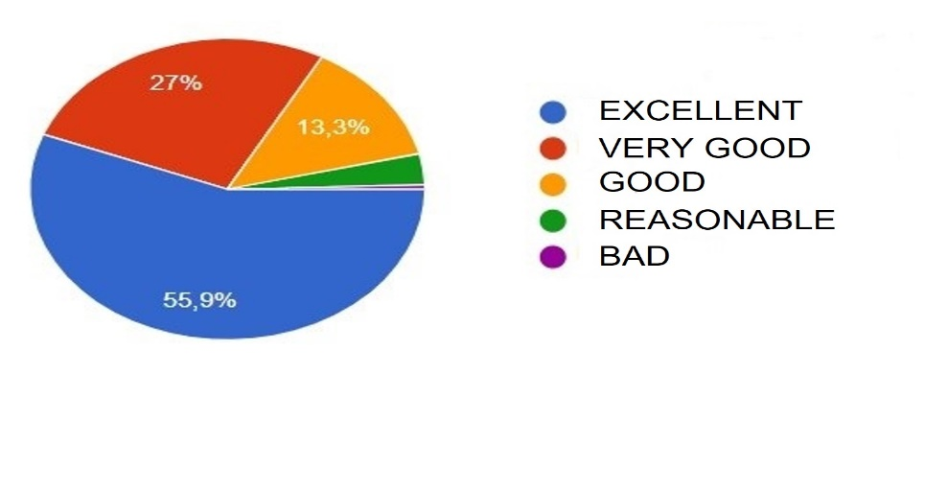
Figure 1. Percentage of consumer responses regarding the evaluation of the use of native plant sources in the development of new products. Source: The authors.

As for the main reasons that were considered important to justify the use of these raw materials, the following stand out: environmental sustainability (64.5%) followed by income generation for the local population (57.3%) (Figure 2). This reinforces the idea that consumers understand that the development of new products must be aligned with environmental issues, in addition to promoting the improvement of the quality of life and work of the populations that depend on these crops as a source of income. Some studies have already reported that the growth of consumer perception regarding the origin, safety, and quality of food and what affects this production has on the environment (11, 12, 13, 14). Health concerns (42.7%) were also given as a reason for using native plant sources in plant-based products. According to PINTO et al., (15) the increased perception of the healthiness of foods is driving current and future food choices.

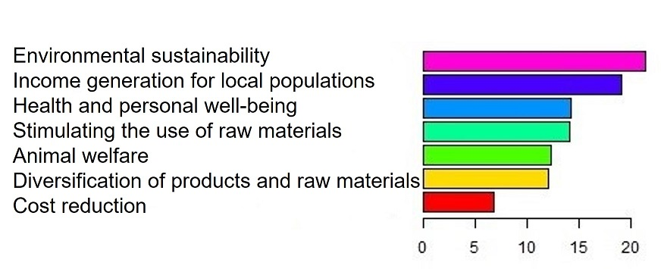
Figure 2. Main reasons pointed out by the participants as the main ones for the use of native sources from Brazilian biomes. Source: The authors.

To verify the potential of plant sources, the participants were asked about which sources are considered more important for the development of new products, in which fruits (43.6%) and nuts (37.4%) were the main alternatives to be used as raw materials for plant-based foods. There is a diversity of nuts and fruits that are little explored and often unknown by the majority of the population. Thus, developing products from these and other sources will promote an increase in the diversity of plant-based products and allow the commercial expansion of these products to regions different from those where the plant sources are traditionally produced, leading to the popularization of their consumption.
Of the participants, 35% (n=74) indicated that they have already consumed or are interested in consuming plant-based ice cream made from plants, of which 8% (n=6) declared to be vegan, 23% (n=17) vegetarians, and 63% (n=47) flexitarians. Interestingly, this higher propensity of omnivorous consumers indicates that such products may be attractive, regardless of the type of diet, showing a more general and growing interest in options without animal raw materials. The substitution of animal ingredients for vegetable sources with technological and nutritional potential in plant-based ice cream can provide health benefits to consumers. In this sense, sources native to the Brazilian biomes, such as nuts and exotic fruits, can be an alternative not only to expand the diversity of products but also to stimulate food security, as well as improve the productivity and income of small producers, strengthening and adding value to the new products developed.

CONCLUSION
The use of a questionnaire to obtain the perception of consumer behavior about the use of native sources from the Brazilian biome for the development of plant-based ice creams indicated interesting results. Consumers said that the use of these sources, especially native nuts and fruits, for the development of products is positive. Environmental sustainability, income generation for the local population and health, and personal well-being were the main reasons for using alternative vegetable sources. Thus, by boosting the development of plant-based products from the valorization of the diversity of fruits, nuts, and seeds little explored from the Brazilian biome it is possible to add value to products, foster sustainable development, generate income, and popularizing these raw materials.
Therefore, the results of this study can help in the development of indulgent plant-based ice creams that claim to be more indulgent, sustainable, healthy, and aligned with consumer desires.

ACKNOWLEDGMENTS
The authors would like to thank the Federal Agency for Support and Evaluation of Graduate Studies in Education (CAPES), FAPEMIG, CNPq/Brazil.

BIBLIOGRAPHIC REFERENCE

- GOFF, H. D. Ice Cream and Frozen Desserts. Dairy Processing and Quality Assurance, [S. l.], p. 357–386, 2009. DOI: 10.1002/9780813804033.ch16.
- HARTEL, R. W.; RANKIN, S. A.; BRADLEY, R. L. A 100-Year Review: Milestones in the development of frozen desserts. Journal of Dairy Science, [S. l.], v. 100, n. 12, p. 10014–10025, 2017. DOI: 10.3168/jds.2017-13278. Disponível em: http://dx.doi.org/10.3168/jds.2017-13278.
- PIMENTEL, T. C.; GOMES DE OLIVEIRA, L. I.; CARVALHO DE SOUZA, R.; MAGNANI, M. Probiotic non-dairy frozen dessert: Technological and sensory aspects and industrial challenges. Trends in Food Science and Technology, [S. l.], v. 107, n. October 2020, p. 381–388, 2021. DOI: 10.1016/j.tifs.2020.11.008. Disponível em: https://doi.org/10.1016/j.tifs.2020.11.008
- RODRIGUES ARRUDA PINTO, V. et al. Contemporary foods – Can they become new comfort foods or simply mimic them? International Journal of Gastronomy and Food Science, v. 22, p. 100271, dez. 2020.
- WANG, G. et al. Consumers’ Experiences and Preferences for Plant-Based Meat Food: Evidence from a Choice Experiment in Four Cities of China. Journal of Integrative Agriculture, set. 2022.
- CHEZAN, D.; FLANNERY, O.; PATEL, A. Factors affecting consumer attitudes to fungi-based protein: A pilot study. Appetite, v. 175, p. 106043, ago. 2022.
- SILVA, A. R. A.; SILVA, M. M. N.; RIBEIRO, B. D. Health issues and technological aspects of plant-based alternative milk. Food Research International, v. 131, p. 108972, maio 2020.
- SIPPLE, L. R. et al. Consumer perception of ice cream and frozen desserts in the “better-for-you” category. Journal of Dairy Science, v. 105, n. 1, p. 154–169, jan. 2022.
- PEREZ-CUETO, F. J. A. et al. How barriers towards plant-based food consumption differ according to dietary lifestyle: Findings from a consumer survey in 10 EU countries. International Journal of Gastronomy and Food Science, v. 29, p. 100587, set. 2022.
- NOGUEROL, A. T. et al. Green or clean? Perception of clean label plant-based products by omnivorous, vegan, vegetarian and flexitarian consumers. Food Research International, v. 149, p. 110652, nov. 2021.
- MESÍAS, F. J.; MARTÍN, A.; HERNÁNDEZ, A. Consumers’ growing appetite for natural foods: Perceptions towards the use of natural preservatives in fresh fruit. Food Research International, v. 150, p. 110749, dez. 2021.
- PETRESCU, D. C.; VERMEIR, I.; PETRESCU-MAG, R. M. Consumer Understanding of Food Quality, Healthiness, and Environmental Impact: A Cross-National Perspective. International Journal of Environmental Research and Public Health, v. 17, n. 1, p. 169, 25 dez. 2019.
- TRUONG, V. A.; LANG, B.; CONROY, D. M. When food governance matters to consumer food choice: Consumer perception of and preference for food quality certifications. Appetite, v. 168, 1 jan. 2022.
- VAN BUSSEL, L. M. et al. Consumers’ perceptions on food-related sustainability: A systematic review. Journal of Cleaner Production, v. 341, p. 130904, mar. 2022.
- PINTO, V. R. A. et al. Perceived healthiness of foods: A systematic review of qualitative studies. Future Foods, v. 4, p. 100056, dez. 2021.

